EC-231 Operating Systems
BS(CE)-2021
LAB REPORT # 1

Submitted By:
Reg. No. | Name
21-CE-009 | Huzaifa Shahbaz
Department of Computer Engineering
BS Computer Engineering Program
HITEC University Taxila
 | Presentation  (Format (0.5) + Title (0.5) +  Conclusion(1) + Procedure(2) + Objective(1)) | Calculation/Coding | Observation/ Program Results | Total
Total | 5 | 5 | 5 | 15
Obtained

___________________________
Lab Instructor.
Engr. Fasih Ahmad

Experiment #1
Linux Shell commands for file operations and their rights
Objective: The main objectives of this lab are to understand: 1. How to view or edit a text file in Linux. 2. How we can concatenate two or more files into a single file, 3. How to sort contents of file 4. How to display specific lines of a file 5. How to assign different permissions to the file using commands in Ubuntu operating system.

Software Used: 1. Ubuntu 2. Virtual box

Procedure: 1.ls: Use the `ls` command to list files and directories in the current directory. It provides information about file names, sizes, and permissions. 2.chmod: The `chmod` command is used to change the permissions of files and directories. It allows you to specify who can read, write, or execute a file. 3. chown: With the `chown` command, you can change the ownership of a file or directory. This command is often used to transfer ownership between users or groups. 4. cp: Use the `cp` command to copy files and directories from one location to another. It creates a duplicate of the file or directory with the specified permissions. 5.mv: The `mv` command is used to move files and directories from one location to another. It also allows you to rename files and directories. 6.rm: Use the `rm` command to remove files and directories from the system. Be cautious when using this command, as it permanently deletes the specified files. 7. mkdir: The `mkdir` command is used to create new directories. You can specify the name and permissions of the directory to be created. 8. rmdir: Use the `rmdir` command to remove empty directories from the system. Similar to the `rm` command, be careful when using `rmdir` as it deletes directories permanently. Understanding file permissions: 1. In Linux, file permissions are represented by three sets of characters: user, group, and others. 2.Each set can have three permissions: read (r), write (w), and execute (x). 3.The `ls -l` command displays file permissions in the format `drwxr-xr-x`, where the first character indicates the file type, followed by three sets of permissions for user, group, and others. Understanding file ownership: 1.Each file and directory in Linux has an owner and a group associated with it. 2.The `chown` command allows you to change both the owner and the group of a file or directory. These commands and concepts form the foundation for managing files and directories in a Linux environment, enabling users to control access and organization effectively.

Tasks
Task 1: Show Simulation results after performing the following tasks by using suitable commands in Linux. Also show command/commands used for specific task a. Create a blank text file on your home directory with your name. b. Make a directory with name student. c. Change the directory to student and copy your text file in this directory. d. Assign no permission to anyone. e. Verify that above task has done successfully. f. Now try to write in this file. If error occurs, state why? g. Assign permission of write only to user h. Verify that above task has done successfully. i. Write your introduction in 5 to 7 lines in .txt file. j. Display contents of the file. If error occurs, state why? k. Assign permission of read only to user l. Verify that above task has done successfully. m. Display contents of the file. n. Assign permissions of read and execute only to user o. Verify that above task has done successfully. p. Assign permissions of read and write only to user q. Verify that above task has done successfully. r. Assign all permissions to user s. Verify that above task has done successfully. t. Assign permission of read and execute only to group u. Verify that above task has done successfully. v. Assign all permissions to all users w. Verify that above task has done successfully. Stimulation: 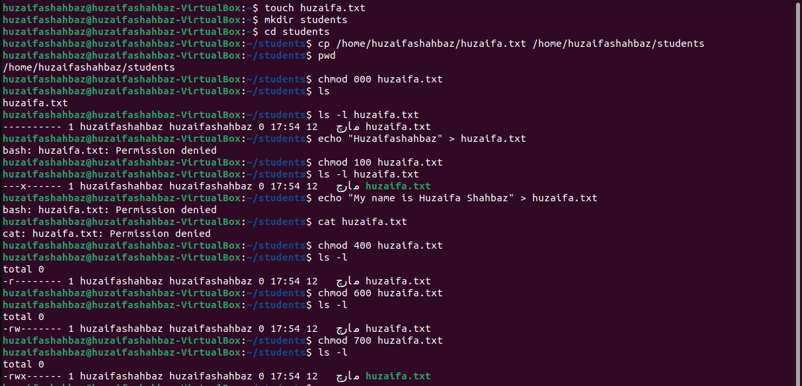 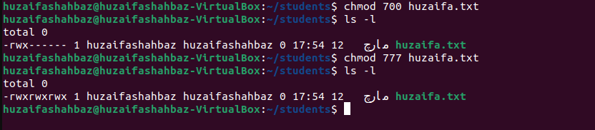

Conclusion: In conclusion, Linux shell commands allow for efficient file operations such as creating, copying, relocating, and deleting files, as well as managing file permissions with chmod and chown. These commands allow users to effectively alter files, directories, and permissions, which improves system security and organization. Understanding and using these commands is required for effective file management and system administration in Linux systems.

